**GAME ZONE**



A project report submitted to

Rajiv Gandhi Proudyogiki Vishwavidhyalay,Bhopal

towards partial fulfillment of

the degree of

**MASTER OF COMPUTER APPLICATION**

**{2019-2022}**

**Submitted by:**

Diksha Joshi

**Guided By:**

Mr.Upendra Singh

*Department of Information Technology*

Department Of InformationTechnology

**SHRI G.S. INSTITUTE OF TECHNOLOGY AND SCIENCE**

**INDORE (M.P.)**

**SHRI G.S. INSTITUTE OF TECHNOLOGY AND SCIENCE**

**INDORE (M.P.)**



**Recommendation**

The project report entitled **“*GAME ZONE*”** submitted by **DIKSHA JOSHI** students of **MCA** 2nd year in the session 2019-22, towards partial fulfillment of the degree of **Master of Computer Applications** of **Rajiv Gandhi Proudyogiki Vishwavidhyalaya**,**Bhopal** is a satisfactory account of her work and is recommended for the award of degree**.**

**Mr.Upendra Singh**

Project Guide

Department Of Information Technology

**Head**

Department Of Information Technology

**INDORE (M.P.)**

**SHRI G.S. INSTITUTE OF TECHNOLOGY AND SCIENCE**

**INDORE (M.P.)**



**Certificate**

The project report entitled **“*GAME ZONE*”** submitted by **Diksha Joshi** students of **MCA** 2nd year in the session 2019-2022, towards partial fulfillment of the degree of **Master of Computer Applications** of **Rajiv Gandhi Proudyogiki Vishwavidhyalaya**,**Bhopal**, is a satisfactory account of their work and is approved for award of the degree.

**Internal Examiner External Examiner**

**Acknowledgement**

We are heartily pleased to acknowledge all those people who have helped us in the successful completion of this project. With great pleasure we express our heartfelt gratitude to our esteemed guide, **Mr.Upendra singh** Lecturer Department of Computer Technology & Application, S.G.S.I.T.S. Indore. Her persistent encouragement, perpetual motivation, everlasting patience and valuable technical inputs in discussions have enabled the successful completion of this project. Her invaluable help, advice and constant encouragement helped us a lot and provide impetus to the progress of the project. We extend our profound indebtedness to the Head of the department **Ms. Sunita Verma,** the word loose their worth for her invaluable guidance, continuous encouragement and cooperation in every respect.

We sincerely wish to express our gratitude to all the members of staff of M.C.A.who have extended their cooperation at all times and have contributed in their own way in developing the project. Successful completion of a project is not an individual effort. It is an outcome of the cumulative effort of a number of persons, each having his own importance to the objective. We are thankful to our parents for being a constant source of encouragement in all our endeavors. Indeed it is their support that helps us through the ups and downs of life. The support and suggestion of our friends are worth appreciation and thankfulness. *A blend of gratitude, pleasure, great satisfaction and indebtedness is what, we feel to convey to all those who have directly or indirectly contributed to the successful completion of our project work.*

**Diksha Joshi**

**Abstract**

**GAME ZONE is gaming software build on java and runs on terminal only.**

**In this gaming program or software we play different types of game. This**

**program makes user to learn different games with help of coding technology.**

**This project consist of number of games to learn gaming programming and how**

**any gaming software work.**

***Table of Contents***

1. **Introduction**

1. **Features**
2. **Diagrams**
3. **Coding**
4. **Outputs**
5. **References**

**Introduction**

* 1. **Objective**

Te aim of this project is to implement a program which provide gaming zone to play

different games.

* 1. **Scope**

The software can be used to make different games like open any game and start

playing. We have different options of games in this software to switch from one to other

game in this software.The benefits of this is to create a secure and reliable game zone.

* 1. **Technologies Used**

JAVA

**Features**

1. Rock, Paper and Scissor.
2. Number guessing game.
3. Die and Dice.
4. Hangman.
5. General knowledge quiz.

**Diagrams**

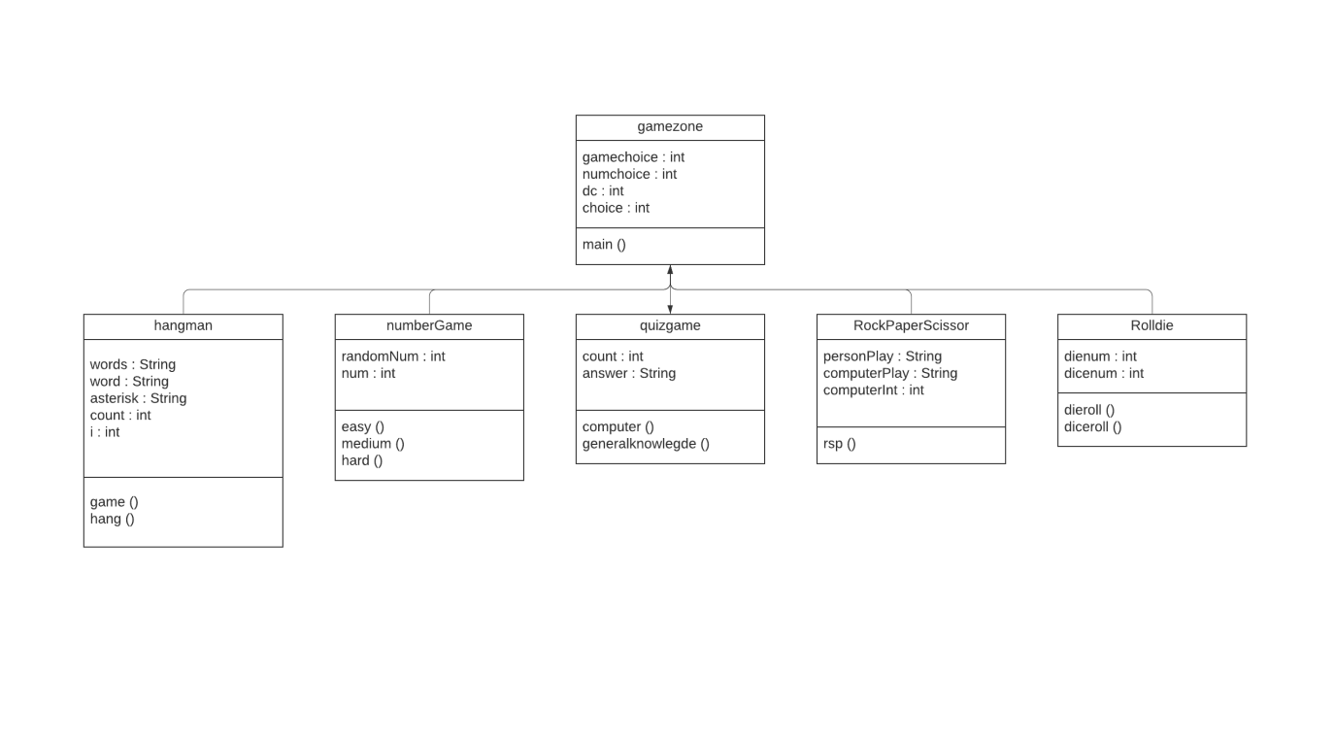

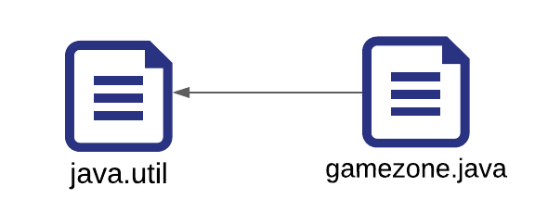

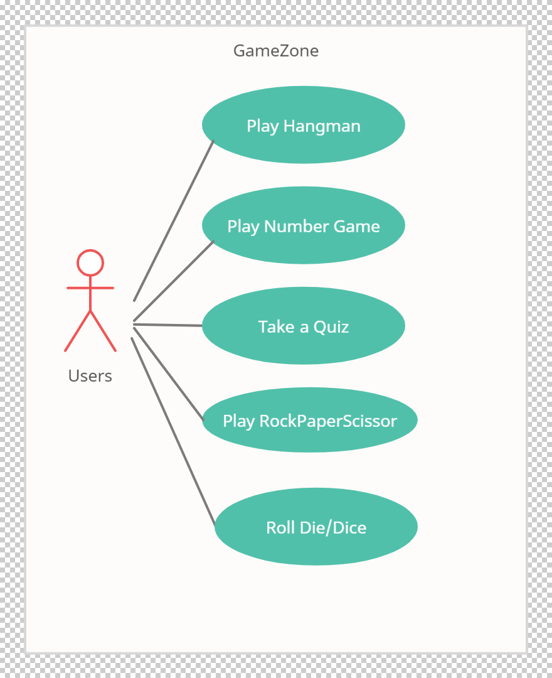

**Coding**

import java.util.Locale;

import java.util.Scanner;

import java.util.Random;

public class gamezone {

static class RockPaperScissor {

void rsp() {

String personPlay; //User's play -- "R", "P", or "S"

String computerPlay = ""; //Computer's play -- "R", "P", or "S"

int computerInt; //Randomly generated number used to determine

//computer's play

String response;

Scanner scan = new Scanner(System.in);

Random generator = new Random();

System.out.println("Hey, let's play Rock, Paper, Scissors!\n" +

"Please enter a move.\n" + "Rock = R, Paper" +

"= P, and Scissors = S.");

System.out.println();

//Generate computer's play (0,1,2)

computerInt = generator.nextInt(3) + 1;

//Translate computer's randomly generated play to

//string using if //statements

if (computerInt == 1)

computerPlay = "R";

else if (computerInt == 2)

computerPlay = "P";

else if (computerInt == 3)

computerPlay = "S";

//Get player's play from input-- note that this is

// stored as a string

System.out.println("Enter your play: ");

personPlay = scan.next();

//Make player's play uppercase for ease of comparison

personPlay = personPlay.toUpperCase();

//Print computer's play

System.out.println("Computer play is: " + computerPlay);

//See who won. Use nested ifs

if (personPlay.equals(computerPlay))

System.out.println("It's a tie!");

else if (personPlay.equals("R"))

if (computerPlay.equals("S"))

System.out.println("Rock crushes scissors. You win!!");

else if (computerPlay.equals("P"))

System.out.println("Paper eats rock. You lose!!");

else if (personPlay.equals("P"))

if (computerPlay.equals("S"))

System.out.println("Scissor cuts paper. You lose!!");

else if (computerPlay.equals("R"))

System.out.println("Paper eats rock. You win!!");

else if (personPlay.equals("S"))

if (computerPlay.equals("P"))

System.out.println("Scissor cuts paper. You win!!");

else if (computerPlay.equals("R"))

System.out.println("Rock breaks scissors. You lose!!");

else {

System.out.println("Invalid user input.");

}

}

}

static class numberGame{

Scanner sc = new Scanner(System.in);

Random generator = new Random();

void easy(){

//Generate computer's number

int randomNum = generator.nextInt(5) + 1;

System.out.println("enter a number between 1 to 5");

int num = sc.nextInt();

if (num == randomNum) {

System.out.println(" Hurrey.... Number matched. You win \n");

} else {

System.out.println("Oops, numbers do not matched. You lost \n");

System.out.println("The number was " + randomNum);

}

}

void medium(){

//Generate computer's number

int randomNum = generator.nextInt(10) + 1;

System.out.println("enter a number between 1 to 10");

int num = sc.nextInt();

if (num == randomNum) {

System.out.println(" Hurrey.... Number matched. You win \n");

} else {

System.out.println("Oops, numbers do not matched. You lost \n");

System.out.println("The number was " + randomNum);

}

}

void hard(){

//Generate computer's number

int randomNum = generator.nextInt(15) + 1;

System.out.println("enter a number between 1 to 15");

int num = sc.nextInt();

if (num == randomNum) {

System.out.println(" Hurrey.... Number matched. You win \n");

} else {

System.out.println("Oops, numbers do not matched. You lost \n");

System.out.println("The number was " + randomNum);

}

}

}

static class RollDie{

Scanner sc = new Scanner(System.in);

Random generator = new Random();

void dieroll(){

//Generate random die number (0,1,2,3,4,5)

int dienum = generator.nextInt(6) + 1;

System.out.println("The number on Die is " + dienum);

}

void diceroll(){

//Generate random die number (0 - 11)

int dicenum = generator.nextInt(12) + 1;

if (dicenum ==1)

dicenum = dicenum + 1;

System.out.println("The sum of numbers on Dice is " + dicenum);

}

}

static class hangman

{

static String[] words = {"terminator", "banana", "computer", "cow", "rain", "water"};

static String word = words[(int) (Math.random() * words.length)];

static String asterisk = new String(new char[word.length()]).replace("\0", "*");

static int count = 0;

public static void game(){

Scanner sc = new Scanner(System.in);

while (count < 7 && asterisk.contains("*")) {

System.out.println("Guess any letter in the word");

System.out.println(asterisk);

String guess = sc.next();

hang(guess);

}

sc.close();

}

public static void hang(String guess) {

String newasterisk = "";

for (int i = 0; i < word.length(); i++) {

if (word.charAt(i) == guess.charAt(0)) {

newasterisk += guess.charAt(0);

} else if (asterisk.charAt(i) != '*') {

newasterisk += word.charAt(i);

} else {

newasterisk += "*";

}

}

if (asterisk.equals(newasterisk)) {

count++;

System.out.println("you have "+ (7-count)+" try remaining");

} else {

asterisk = newasterisk;

}

if (asterisk.equals(word)) {

System.out.println("Correct! You win! The word was " + word);

}

if (count==7)

{

System.out.println("GAME OVER! The word was " + word);

}

}

}

static class quizgame

{

Scanner sc = new Scanner(System.in);

int count = 0;

String answer;

void computer()

{

System.out.println("********** Enter your Responce by pressing A/B/C/D **********\n\n ");

System.out.println("Q1. \"Connecting people\" is the tagline of ....\n" +

"A. Nokia\n" +

"B. Samsung\n" +

"C. Apple\n" +

"D. Xiaomi\n");

answer = sc.next();

answer = answer.toUpperCase();

if (answer.equals("A"))

count++;

System.out.println("Q2. What is the shortcut key combination to open File Explorer in windows ?\n" +

"A. Ctrl + A\n" +

"B. Ctrl + E\n" +

"C. Ctrl + F\n" +

"D. Ctrl + Shift + E\n");

answer = sc.next();

answer = answer.toUpperCase();

if (answer.equals("B"))

count++;

System.out.println("Q3. What does ASCII stand for?\n" +

"A. American Standard Code for Information Interchange\n" +

"B. American Scientific Code for Information Interchange\n" +

"C. American Scientific Code for Interchanging Information\n" +

"D. American Standard Code for Interchanging Information\n");

answer = sc.next();

answer = answer.toUpperCase();

if (answer.equals("A"))

count++;

System.out.println("Q4. Which of the following is the another name for a PEN Drive?\n" +

"A. USB Flash Drive\n" +

"B. Gig stick\n" +

"C. Thumb Drive\n" +

"D. All of the Above\n");

answer = sc.next();

answer = answer.toUpperCase();

if (answer.equals("D"))

count++;

System.out.println("Q5. Who invented Java?\n" +

"A. Guido Vann Rossam\n" +

"B. James Gosling\n" +

"C. Mark Zukerburg\n" +

"D. Tim Cook\n");

answer = sc.next();

answer = answer.toUpperCase();

if (answer.equals("B"))

count++;

System.out.println("Your Result total is : "+count+"\n");

}

void generalKnowledge()

{

System.out.println("********** Enter your Responce by pressing A/B/C/D **********\n\n ");

System.out.println("Q1. How many union territories are there in India ?\n" +

"A. six\n" +

"B. Seven\n" +

"C. Nine\n" +

"D. Eight");

answer = sc.next();

answer = answer.toUpperCase();

if (answer.equals("C"))

count++;

System.out.println("Q2. Which of the following is the capital of Arunachal Pradesh?\n" +

"A. Itanagar\n" +

"B. Dispur\n" +

"C. Imphal\n" +

"D. Panaji\n");

answer = sc.next();

answer = answer.toUpperCase();

if (answer.equals("A"))

count++;

System.out.println("Q3. What is the state flower of Haryana\n" +

"A. Lotus\n" +

"B. Rhodedendron\n" +

"C. Golden Shower\n" +

"D. Not Declared\n");

answer = sc.next();

answer = answer.toUpperCase();

if (answer.equals("A"))

count++;

System.out.println("Q4. Which is the largest coffee producing state in india ?\n" +

"A. Kerela\n" +

"B. Karnataka\n" +

"C. Tamil Nadu\n" +

"D. Arunachal Pradesh\n");

answer = sc.next();

answer = answer.toUpperCase();

if (answer.equals("B"))

count++;

System.out.println("Q5. Which indian state has largest area ? \n" +

"A. Maharashta\n" +

"B. Madhya Pradesh\n" +

"C. Uttar Pradesh\n" +

"D. Rajasthan\n");

answer = sc.next();

answer = answer.toUpperCase();

if (answer.equals("D"))

count++;

System.out.println("Your Result total is : "+count);

}

}

public static void main(String[] args) {

Scanner sc = new Scanner(System.in);

RockPaperScissor rps = new RockPaperScissor();

numberGame ng = new numberGame();

RollDie rd = new RollDie();

hangman hang = new hangman();

quizgame q= new quizgame();

System.out.println("**********Game Lists**********\n" +

"Press 1 to play Rock Paper Scissor \n" +

"Press 2 to play Number guessing game\n" +

"Press 3 to roll Die/Dice\n" +

"Press 4 to play Hangman\n" +

"Press 5 to play General Knowledge quiz\n");

int gameChoice = sc.nextInt();

switch (gameChoice){

case 1 : rps.rsp();

break;

case 2 :

System.out.println("Press 1 for easy level (1 - 5)\n" +

"Press 2 for medium level (1 - 10)\n" +

"Press 3 for hard level (1 - 15)");

int numchoice = sc.nextInt();

if (numchoice ==1)

ng.easy();

else if(numchoice == 2)

ng.medium();

else if (numchoice ==3)

ng.hard();

else

System.out.println("you have entered wrong choice");

break;

case 3 :

System.out.println("Press 1 for single Die ( 1 - 6)\n" +

"Press 2 for dice (1 -12 )");

int dc = sc.nextInt();

if (dc ==1)

rd.dieroll();

else if(dc == 2)

rd.diceroll();

else

System.out.println("you have entered wrong choice");

break;

case 4:

hangman.game();

break;

case 5:

System.out.println("Press 1 for Computer quiz\n" +

"Press 2 for India General Knowledge quiz\n");

int choice = sc.nextInt();

if (choice==1)

q.computer();

else if (choice==2)

q.generalKnowledge();

else System.out.println("invalid choice");

break;

default:

System.out.println("you have entered wrong choice");

}

}

}

**Outputs**

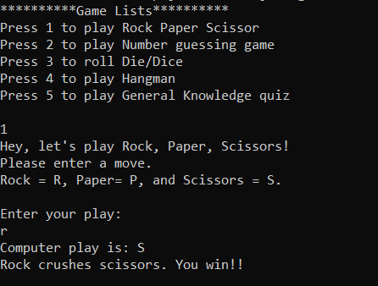

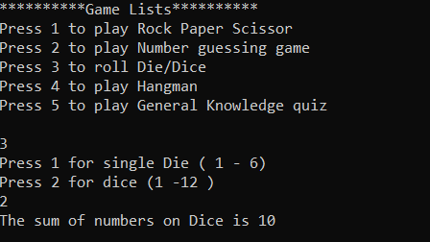

**References**

[www.google.com](http://www.google.com)

[www.javatpoint.com](http://www.javatpoint.com)